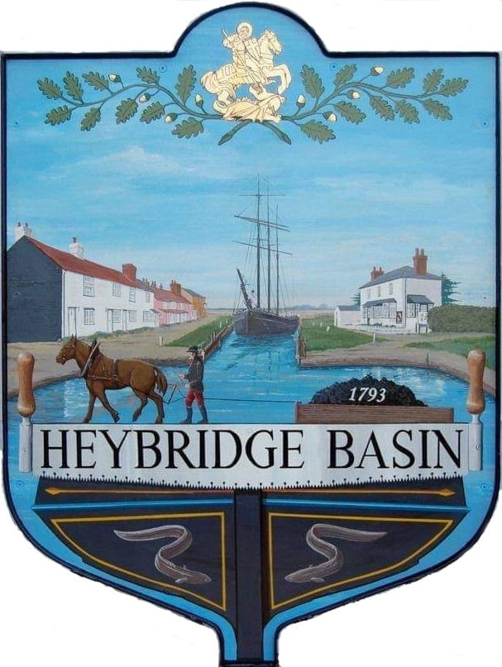

HEYBRIDGE BASIN PARISH COUNCIL

Minutes of the Full Council meeting of Heybridge Basin Parish Council held on Friday 19th July 2024 at 06:30pm, at The Lock Tearoom.

PRESENT

In the Chair: M. Hodges (Chair) Absent: 0

Councillors: R. Bryson (Vice Chair) Apologies: 3
C. Edmond
M. Hobden Public: 4

Officers: G. Lake – Clerk District Cllrs: 2

It was noted that this meeting was being recorded by the Clerk.

24/041 Chair’s Welcome.
The Chair opened the meeting and informed members of the public that they were to speak during the public forum section only, and due to the length of the Agenda members of the public and Council were to keep to the point.

24/042 To note apologies for absence.
Cllrs Swann, Howat and Sjollema.

24/043 To receive Declarations of Interest in accordance with the Council’s Code of Conduct and with section 106 of the Local Government Finance Act 1992.
Cllr Hobden – Non-Pecuniary – HBSA, Basin Oars and HB River care and Cllr Edmond – Non-Pecuniary – Essex Waterways and Director of Cloughton Court Management.

24/044 To sign as a correct record the minutes of the full council meeting held on 18th June 2024.
The Minutes as previously circulated were agreed as a correct record.

24/045 To receive a report from:
- District Councillors - A report was received and circulated from the District Councillors.
- County Councillor – There was no report from Cllr Durham.
- Essex Association of Local Councils (EALC) Representative – Cllr Hafiz was absent.

24/046 Finance.
- To approve
- Payment requests for June/July 2024
The Payment requests as previously circulated were approved.
- Receipts for June/July 2024
The receipts as previously circulated were approved.
- Accounts for the three months to 30th June 2024
The accounts as previously circulated were approved.

- To discuss the change to the Unity Bank Tariff and agree any action to be taken.
The Council’s turnover is above the T1 allowance, and from 18th September 2024 Unity Bank are moving the Council to the T2 tariff, the £6.00 a month charge remains the same with the addition of being charged 15p per individual transaction. There was no action to be taken, members noted the change.
- To receive an update by the RFO regarding the £85,000 FSCS limit and agree any action to be taken.
It was noted that as of 30th June 2024 the Council was above the FSCS limit. It was resolved for the Clerk to research alternative banking arrangements for the Council’s Reserves.

24/047 Public Forum (15 minutes)
Members of the Public will be given an opportunity to put forward their question(s) or statement to the Council. The Chair will at their discretion then decide if they are able to answer the question(s) or proposes to put the item on the agenda for the next meeting.

1 member of public (MOP) raised questions regarding publication of the papers circulated to members and stated they should be available on the website for public to see.
They also questioned why the responses to the two emails were being discussed in private session stating there was no valid reason for the public to be excluded and requested that this be amended. Lastly, they Informed the Council of the Conservation Society’s views on the planning applications on the agenda.

The 2nd MOP informed the Council that they had contacted the ICO (Information Commissioners Office) regarding documents the Council should routinely be publishing on the website.
They also informed the Council that they had spoken to RCCE who said there is funding available for the URC.

The 3rd MOP urged the PC to accept the Section 106 offer and leave the land as a nature reserve as this would involve the least maintenance expense and would cover the developer’s bio-diversity net gain.

The Chair thanked members of the public for their comments and questions. The Clerk explained that responses would either be emailed or on the next Agenda for discussion. The Clerk explained the reasons for the emails being discussed in private session.

24/048 Planning Applications
- To consider any planning applications received after the publication of the agenda and to agree the action to be taken.

Councillor Edmond left the meeting.

24/00527/FUL – The Old Ship – Demolition of existing outbuilding and construction of new boundary wall.
It was resolved that the Council would recommend the refusal of planning permission for this application as it would have a detrimental effect on listed buildings and a Conservation area. Due to its age, it requires special attention, with the Council’s preference of it being rebuilt as it is.

Councillor Edmond returned to the meeting.

24/00433/HOUSE – 15 St Georges Close – Removal of existing conservatory and construction of single storey extension.
It was resolved for the Council to respond with no comment on this planning application.

Councillor Edmond left the meeting.

24/049 Timber Yard – Section 106 Survey
  - To discuss the findings of the village survey and agree any action to be taken.
The findings of the survey were previously circulated to members and were distributed to members of public at the meeting. The findings can be found on the Council’s website. A total of 57 households responded.
It was resolved for the Council to do more research prior to making a decision regarding the Section 106 offer.

  - To note the two emails received regarding the Timber Yard and Section 106 Survey.
The two emails were noted.

Councillor Edmond returned to the meeting.

24/050 Daisy Meadow Car Park (DMCP)
  - To receive an update from the Working Group and agree any action to be taken.
The Haydn Evans Site Visit took place on Thursday 11th July 2024 with the report due back by Friday 26th July 2024.
Camway returned with their fencing contractors and the fencing has been corrected.

The areas for planting still require de-weeding, Cllr Hobden is arranging volunteers to assist. Planting is due to commence in September/October.

The Working Group have been researching car park operators as the contract with Smart Parking is due for potential renewal. It was resolved for the Working Group to post on the government find a tender website to aid their research.

It was resolved for the Clerk to contact UK Power Network regarding erecting fencing around the transformer.
  - To discuss the bridge erected from Square Cottage to the car park and agree any action to be taken.
The owner of the bridge had not provided the Council with the requested and required public liability insurance. It came to the Council’s attention that permission would also require granting from the Environment Agency.
It was resolved for the Clerk to write a letter to the owner requesting the bridge to be removed before the sale of the house is completed and changes hands.

1 member of public left.

24/051 Goal Posts/Netball hoop
- To receive an update from the Clerk and agree any action to be taken.
B. Riches agreed to be appointed Health and Safety representative and to perform regular inspections on the goal posts and netball hoop once installed.
The Clerk has applied for funding with the FA Foundation, The National Lottery Fund and Tesco. The Tesco application is on hold until the funds received for the netball hoop are spent.
3 netball hoops were circulated to members for their consideration. It was resolved to purchase the hoop recommended by the Health and Safety representative up to a cost of £300.00.
- To consider the quote from HRS Marine Services and agree any action to be taken.
It was resolved to accept the quote from HRS Marine Services for £475.00 and for the Clerk to organise the installation once the hoop has been delivered.

24/052 VE Day 80th Anniversary
  - To consider hosting an event to celebrate the 80th anniversary of VE Day in May 2025 and agree any action to be taken.
It was resolved that the Council would consider hosting an event and would set up a Working Group consisting of Cllrs Hobden, Bryson, Hodges, Swann, Edmond and the Clerk.

24/053 On Street Parking
- To receive an update from the Working Group and agree any action to be taken.
The application is nearly complete and ready for submission to SEPP (South Essex Parking Partnership). It was resolved to send a letter to the District Councillors requesting their support and to liaise with B. Riches who may have experience with this matter.

24/054 Civility and Respect Pledge
- To receive a report from the Clerk and agree any action to be taken.
It was resolved to not take the pledge and to continue with the Code of Conduct.

24/055 Correspondence
- To note correspondence received and consider any actions to be taken.
Correspondence was noted and responses were agreed.
It was resolved to donate £200.00 from the DMCP account to Heybridge Primary School for their planter project.

24/056 Pursuant to section 1(2) of the Public Bodies (Admission to Meetings) Act 1960 it is resolved that, in view of the confidential nature of the business about to be transacted, it is advisable in the public interest that the press and the public be excluded, and they are instructed to withdraw.

Members of the public left.

24/057 Timber Yard
  - To discuss the two emails received regarding the Timber Yard and Section 106 survey and agree any action to be taken including a formal response.
The two emails were discussed in detail. It was resolved for the Clerk and Cllr Hodges to work together to form a response to both emails.

24/058 Personnel Matters
- To note the Clerk’s accrued holiday entitlement from 2023/2024.
It was noted that the Clerk worked 638.62 hours and would be paid 11.5% in August as per the Clerk’s contract.
- To consider the amendments to the Clerk’s Contract regarding working hours and agree any action to be taken.
It was resolved to approve the amendments to the Clerk's Contract for a 12-month trial starting from 1st of August 2024.

There being no further business the meeting closed at 08:23pm
Provisional Date of the next Council Meeting Tuesday 10th September 2024

Clerk Contact details: clerk@heybridgebasinpc.org.uk
Website: www.heybridgebasin-pc.gov.uk

